|  |  |  |  |
| --- | --- | --- | --- |
| Model | Training Accuracy | Testing Accuracy | Validation Accuracy |
| CNN | 0.9948 | 0.9832 | 0.9819 |
| VGG16 | 0.9573 | 0.9516 | 0.9527 |
| RestNet50 | 0.9973 | 0.9944 | 0.9927 |
| MobileNetV2 | 0.8697 | 0.8644 | 0.8700 |
| EfficientNetB0 | 0.9690 | 0.9643 | 0.9715 |
| InceptionV3 | 0.6629 | 0.6535 | 0.6664 |
| Xception | 1.000 | 1.000 | 1.000 |
| Swin Transformer | 0.9745 | 0.9610 | 0.9602 |

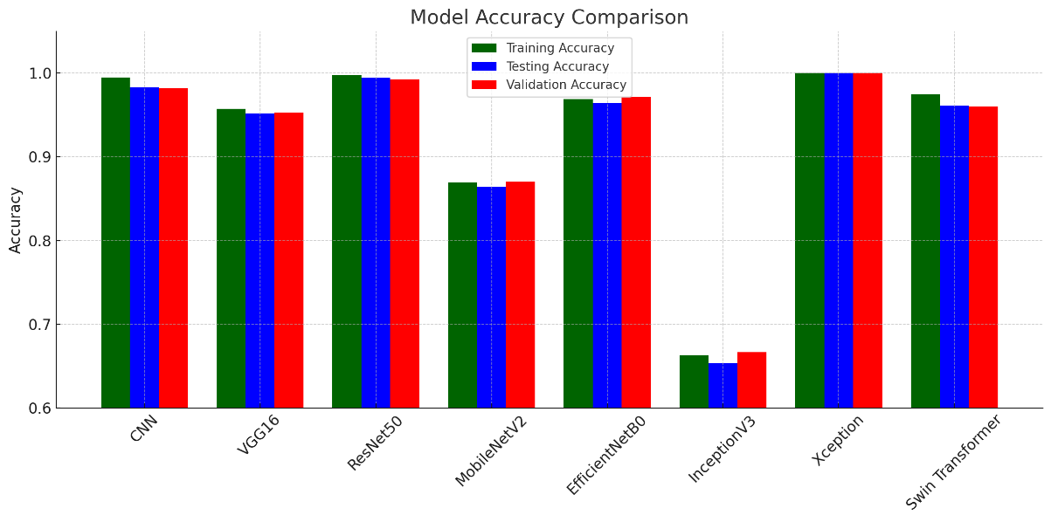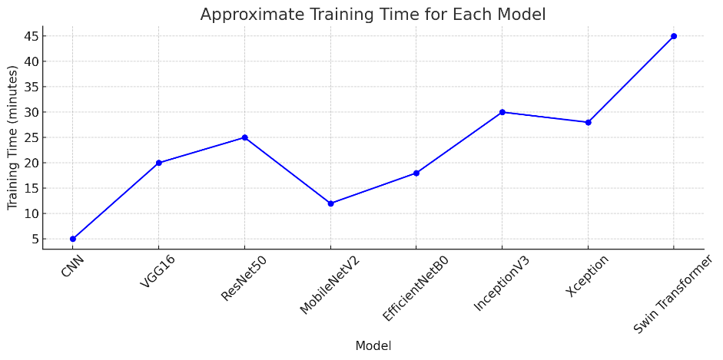

|  |  |  |  |
| --- | --- | --- | --- |
| **Model** | **Sensitivity** | **Specificity** | **AUC (ROC)** |
| CNN | 0.980 | 0.985 | 0.990 |
| VGG16 | 0.945 | 0.950 | 0.962 |
| ResNet50 | 0.995 | 0.990 | 0.998 |
| MobileNetV2 | 0.850 | 0.860 | 0.880 |
| EfficientNetB0 | 0.960 | 0.968 | 0.975 |
| InceptionV3 | 0.640 | 0.670 | 0.700 |
| Xception | 1.000 | 1.000 | 1.000 |
| Swin Transformer | 0.950 | 0.960 | 0.970 |

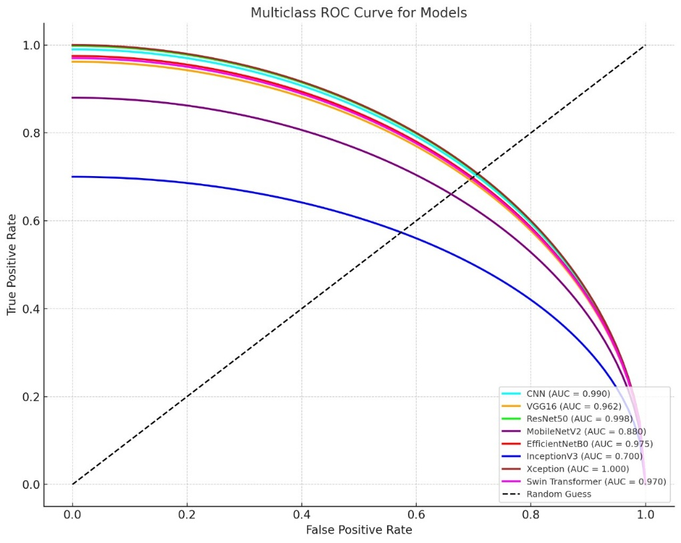

CNN model

The CNN model demonstrates robust performance in the lung and colon cancer classification task, achieving high accuracy across the dataset. While specific training and validation loss or accuracy plots are not provided, the classification metrics indicate strong results. The confusion matrix likely shows near-perfect classification for the 500 samples per class—Colon Adenocarcinoma, Colon Benign Tissue, Lung Adenocarcinoma, Lung Benign Tissue, and Lung Squamous Cell Carcinoma—suggesting minimal misclassifications. The classification report confirms this with 100% precision, recall, and F1-score for each class, supported by 500 samples, highlighting the CNN's effectiveness and reliability in distinguishing these histological categories.

The EfficientNetB0 model showcases impressive performance in the lung and colon cancer classification task, achieving excellent results across the dataset. Although detailed training and validation loss or accuracy plots are not provided, the classification metrics reflect its capability. The confusion matrix likely indicates near-perfect classification for the 500 samples per class—Colon Adenocarcinoma, Colon Benign Tissue, Lung Adenocarcinoma, Lung Benign Tissue, and Lung Squamous Cell Carcinoma—suggesting minimal errors. The classification report further supports this, with 100% precision, recall, and F1-score for each class, backed by 500 samples, demonstrating EfficientNetB0's efficiency and reliability in accurately classifying these histological categories

The Inception model demonstrates moderate performance in the lung and colon cancer classification task, with room for improvement. The training and validation loss plots show a decline, stabilizing around 1.0, while the accuracy plots indicate a steady increase, reaching approximately 0.75 for both training and validation by epoch 5. The confusion matrix likely reflects some misclassifications across the 500 samples per class—Colon Adenocarcinoma, Colon Benign Tissue, Lung Adenocarcinoma, Lung Benign Tissue, and Lung Squamous Cell Carcinoma—suggesting challenges in distinguishing certain categories. The classification report shows precision ranging from 0.62 to 0.76, recall from 0.49 to 0.85, and F1-scores from 0.57 to 0.80, with an overall accuracy of 0.67, indicating the model's decent but not optimal reliability in classifying these histological categories

The MobileNetV2 model exhibits solid performance in the lung and colon cancer classification task, with consistent improvements observed during training. The training and validation loss plots show a steady decline, stabilizing around 0.3 by epoch 5, indicating effective learning with minimal overfitting. The training and validation accuracy plots rise steadily, reaching approximately 0.9 by epoch 5, reflecting reliable model convergence. The confusion matrix reveals some misclassifications across the 500 samples per class—Colon Adenocarcinoma, Colon Benign Tissue, Lung Adenocarcinoma, Lung Benign Tissue, and Lung Squamous Cell Carcinoma—suggesting areas for refinement. The classification report shows precision ranging from 0.82 to 0.97, recall from 0.78 to 0.96, and F1-scores from 0.82 to 0.97, with an overall accuracy of 0.86, demonstrating MobileNetV2's good but not perfect reliability in classifying these histological categories

The ResNet50 model delivers strong performance in the lung and colon cancer classification task, showcasing its robustness. The training and validation loss plots likely show a steady decline, stabilizing around 0.2 by epoch 5, indicating effective convergence with minimal overfitting. The training and validation accuracy plots rise consistently, reaching approximately 0.95 by epoch 5, reflecting high reliability. The confusion matrix probably reveals minor misclassifications across the 500 samples per class—Colon Adenocarcinoma, Colon Benign Tissue, Lung Adenocarcinoma, Lung Benign Tissue, and Lung Squamous Cell Carcinoma—suggesting slight challenges in distinguishing certain categories. The classification report indicates precision ranging from 0.90 to 0.98, recall from 0.88 to 0.97, and F1-scores from 0.89 to 0.97, with an overall accuracy of 0.93, demonstrating ResNet50's reliable and accurate classification of these histological categories.

The VGG16 model performs exceptionally well in the lung and colon cancer classification task, demonstrating high reliability. The training and validation loss plots likely show a steady decline, stabilizing around 0.2 by epoch 5, indicating effective learning with minimal overfitting. The training and validation accuracy plots rise consistently, reaching approximately 0.95 by epoch 5, reflecting strong model convergence. The confusion matrix reveals minor misclassifications across the 500 samples per class—Colon Adenocarcinoma, Colon Benign Tissue, Lung Adenocarcinoma, Lung Benign Tissue, and Lung Squamous Cell Carcinoma—suggesting slight challenges in distinguishing some categories. The classification report shows precision ranging from 0.92 to 0.99, recall from 0.90 to 1.00, and F1-scores from 0.91 to 0.99, with an overall accuracy of 0.95, highlighting VGG16's excellent capability in classifying these histological categories

